**Name – Majahar Mahamud Kazi**

**Div – B Batch – B2**

**Roll no. – 322036 PRN no. – 22110729**

**Assignment 4**

**Aim:** Deploy Web application using S3 Bucket.

**Theory:**

1. **What is S3 service of AWS ?**

Amazon S3 is a Simple Storage Service in[AWS](https://www.geeksforgeeks.org/aws-tutorial/)that stores files of different types like Photos, Audio, and Videos as Objects providing more scalability and security to. It allows the users to store and retrieve any amount of data at any point in time from anywhere on the web. It facilitates features such as extremely high availability, security, and simple connection to [other AWS Services.](https://www.geeksforgeeks.org/top-aws-services/)

**What is Amazon S3 Used for?**

Amazon S3 is used for various purposes in the Cloud because of its robust features with scaling and Securing of data. It helps people with all kinds of use cases from fields such as Mobile/Web applications,[Big data,](https://www.geeksforgeeks.org/what-is-big-data/) [Machine Learning](https://www.geeksforgeeks.org/ml-machine-learning/) and many more. The following are a few Wide Usage of Amazon S3 service.

* **Data Storage:**Amazon s3 acts as the best option for scaling both small and large storage applications. It helps in storing and retrieving the data-intensitive applications as per needs in ideal time.
* **Backup and Recovery:**Many Organizations are using Amazon S3 to backup their critical data and maintain the data durability and availability for recovery needs.
* **Hosting Static Websites:**Amazon S3 facilitates in storing HTML, CSS and other web content from Users/developers allowing them for hosting Static Websites benefiting with low-latency access and cost-effectiveness. To know more detailing refer this Article – [How to host static websites using](https://www.geeksforgeeks.org/how-to-host-static-website-using-aws-s3/).

1. **Step-by-step screenshot to upload static web application on the AWS cloud using S3 service.**

First we need to download a static website from free-css.com

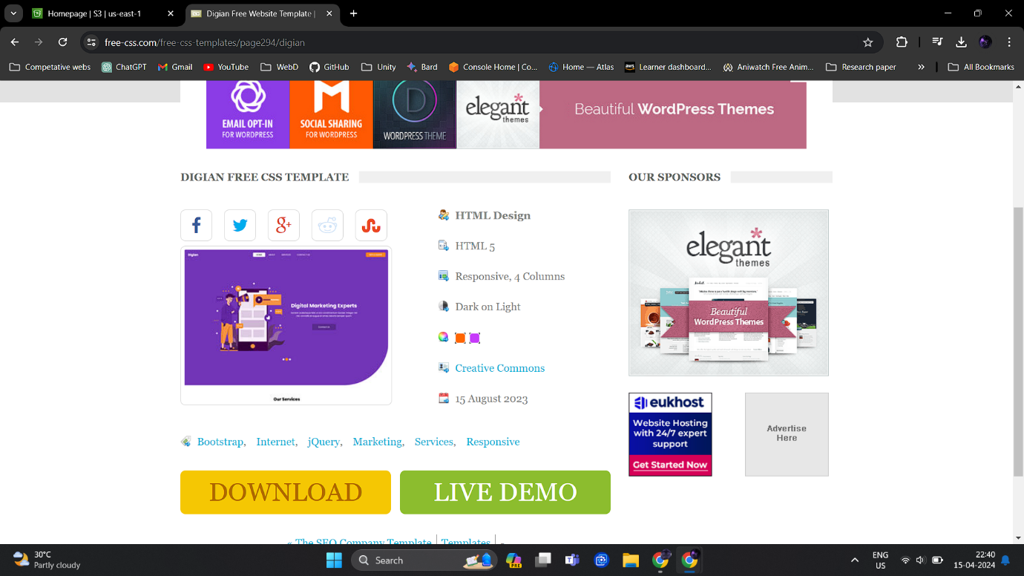

Then we need to create a S3 bucket in aws.

Assign a name to bucket, which should be unique and set the object ownership to acl enabled.

Remove block all public access and accept the setting.

All the required settings are done for out S3 bucket.

After creating bucket open upload section.

Go to add files.

Now upload the downloaded website’s zip file.

From actions do to make public acl section for our web.zip file

Create an EC2 instance and assign a name to it.

Create a key with .ppk extension

In network settings allow traffic from http and https and launch the instance.

Now connect to our created Virtual Machine(VM).

We are into our vm now.

Let’s initialize the vm by updating system and installing httpd.

Let’s download our web.zip file from our S3 bucket. For that we need to copy the url from S3 bucket for our web.zip file.

We got our web’s zip file lets unzip it.

Let’s copy all the files from unzipped folder to var/www/http folder and remove both zip file and unzipped directory.

In end enable httpd for launching our web.

Copy the Auto-assigned IP address for EC2 instance.

**Result:**

Author – Majahar Kazi

MONDAY 15 April 2024 18:04:08 PM IST